ITI - CSS3 Lab Assignment

Task: Build the Following Web Page
Create a web page
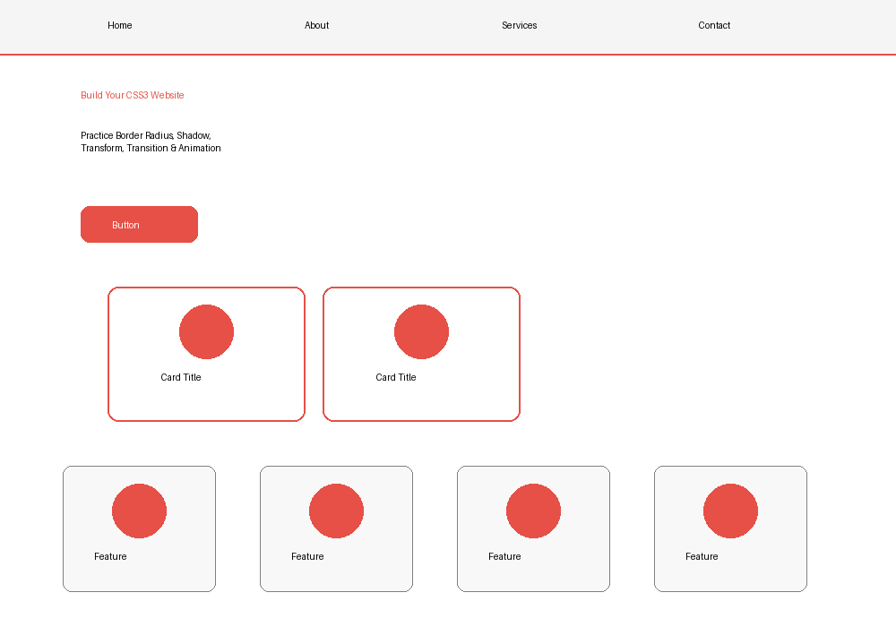

Requirements
- Create a Navigation Bar with four links.
- Create a Hero section with a heading, paragraph and button.
- Apply border-radius and box-shadow to cards.
- On card hover: scale, rotate slightly and increase shadow.
- Add smooth transition effects.
- Rotate each feature icon on hover.
- Animate one element using CSS @keyframes.
- Create a 'Latest News' section using column-count:2.
- Use a Google Font.

